

GFWC JOPPATOWNE WOMAN’S CLUB, INC.

P.O. BOX 268
JOPPA, MD 21085

PETAL POWER
December 2011

“Powerful Women – Volunteering Hands of the Community”

Editor-in-Chief-Dottie Bishoff
Assisting Editor-Ruth Cameron
Federated April 1966
President’s Message Dottie Bishoff
443-402-1421
Dear Club Members:

I want to thank all of you for your prayers and well wishes for my husband Bob. He is doing very well. I also want to thank those who brought us meals, soups, homemade cakes, brownies, a large fruit basket which we both are still enjoying and a restaurant gift card. I am writing this message on the day before Thanksgiving, as you have read we (the Bishoffs') have so so much to be thankful for, our family and our many dear friends who have all been praying for Bob. There is great power in prayer. Thanks to all of you for everything you have done, you are the best!!

Don't forget to bring your ornament for ornament exchange at our December 7th. Meeting (Wednesday). Please remember to bring in a pair of socks in the zip lock bag I handed out at the November meeting. Ladies, remember your spouses are invited to this meeting, we will be having, Dr Johns Musical Memories as our program entertainment. . Cocktails begin at 6:30 p.m. Meeting starts at 7:00 p.m.

All mu best
Dottie

The message of Christmas is that:
The visible material world is bound
to the invisible Spiritual world!!!



December Birthdays

No birthdays in December

Health News:

Dottie Bishoffs' husband Bob received a clean bill of health on November 23rd. what a great Thanksgiving gift. Catheter and staples removed, Dr. said he was the best patient he has had for that type of operation. Dr said "his body has responded like a 40 year old".. Bob and Dottie thank all of you for your many prayers and well wishes.

Barbara Albers has plantar fasciitis on the bottom of her left heel, which is very painful, and making it difficult for her to stand or walk for any length of time. Her 3 yr. old granddaughter has MRSA on her leg which is slow healing. Barbara says 'she is handling it very well for a 3 year old. Barbara's husband Dieter had a TIA or small stroke a couple of weeks ago. He is doing fine.

Ursula Pierce had cataract surgery, is having a problem with the eye the surgery was performed on, was seeing her Dr. concerning the problem. She had surgery on the other eye on Nov. 29th.

Ladies, please keep your club sisters and their families in your prayers.

If anyone is ever in need to borrow a wheel chair call Dee Martin or Joyce Brown



Conservation
Jeanette Petnic-410-679-0959

Chesapeake Bay

Stripped bass are often seen as the greatest story of the Bay. They were always plentiful until the 1980's when there was a decline. A moratorium from 1985 to 1990 caused a rebound. Now there is a limit to the amount than can be caught. Because of water pollution the bass are getting skinny, diseased and dying at a faster rate. They lack good nutrition. The Chesapeake Bay Foundation continues to work to protect our water.

Since I will not be attending the December general meeting, please bring all your recyclables - tabs, towels, blankets, old eye glasses and old cell phones to our January meeting.

Thank you to Maureen Cornett, Barbara Knapp and Jim Panic for participating in the cleaning of our section of road for the Adopt the Road Program


Education;
Barbara Ledford
410-679-1166



Thanks to my committee for reading with the children at Joppetowne Elementary School, and remember, we get a short break; school will be closed from Dec. 23rd. until Jan. 3rd.

Ladies, I wish you all the best Christmas and New Year ever, with lots of family and friends and with no health problems. Happy Holidays

Barbara
Chairman, Education

Public Issues:
Lori Eck
443-484-2054

I have contacted several more veterans' organization, who focuses on women veterans; I will discuss them at the Public Issues meeting on Dec. 5th. at7:00 p.m. at my home.

I would like to thank everyone for the food donations, it was very successful. The family that received the food was a Joppatowne family and they were very very grateful to have received it.

Merlyn from the Extreme Family Outreach contacted to me to thank us for getting her message out to the Joppa community. She has asked if we would help her, she has 10 children that are on her basket list that are in the Joppa area and they are children of Harford County wounded veterans. If you would like to participate, please bring a toy wrapped and marked for boy or girl. We will have another raffle. Please call or e-mail me if you are interested. Thank you ladies; with you we make a difference!



Home Life
Barbara Albers
410-679-5260

You should have seen their faces, when we made our deliveries to Habitat for Humanity and Anna's House. We will probably be doing more projects with both of these organizations in the spring.

Brunch with Santa is coming fast. The set-up is 12/09/11 at 3:00 p.m. and the actual brunch is 12/10/11 at 9:30 a.m., both are being held at the library. If you have signed up to help and you can't make it, please give me a call.

This committee may initiate a Dress for Success project in the New Year. Please save you "work" clothes for us especially suits. Home life meeting at my house on
Jan. 16th. 2012 at 2:00 p.m. to hear more details.

Health Tip: To safeguard your memory: Exercise regularly, consume no more than 1 alcoholic beverage per day, maintain social relationships, and maintain normal blood pressure: Happy Holidays





Finance
Ways & Means
Rosemarie Sebula-410-679-3357
Rose Mary Vaccaro-443-372-5404

Hi Ladies,

Thanks to all our club members for a successful Barnes and Noble Nook Reader raffle. Tickets were sold out very fast, and we will have the drawing on the night of our Christmas dinner meeting.

Rosemary is looking into a bus trip for next year, more info to come at a later date.

I was able to make another deposit with Renders tapes last month, so keep them coming. Thanks again for your support for us and the club in all our endeavors to meet our goals
for this year. Merry Christmas to all

Rose Marie & Rosemary



Art Community Service Program

Loretta Di Loretta.
410-679-2259

Art news not available this issue, will have information in the next Petal Power.


International Outreach Community Service Program

Diane Raycob-410-893-7534
Betty Meidinger-443-922-7706

Second VP- Report-John Hershberger will be performing at our December general meeting. He is a solo musician/vocalist entertainer, he will entertain us before the meeting begins and then follow -up with a sing-a-long of holiday music. Some of us have heard him before at the district meeting and at our 2nd. Annual Tea and Symphony. We are looking forward to seeing him again.
////////////////////////////////////////////////////////////////////////////////////////////////////////////////////////////////

International Outreach Program-
Thanks to all of you who contributed to UNICEF. We will be donating over $100.00 to this organization.

If you are perplexed as to what to give that person who has everything, think about Heifer International. With so many meaningful gifts to choose from, they have something special for everyone on your shopping list. Where else can you find a gift that provides a family in need with dignity of feeding themselves? The means to pay for clothing and education... doctors visits and decent shelters
.
Your heifer gifts not only ignite transformation in faraway places, they also make a lifelong impact closer to home when you make gift in honor of someone near and dear to your heart.

You can give by calling 800-698-2511 or ordering on line at www.heifer.org/catalog, or by mail: Heifer International, P.O. Box 6021 Albert Lea, MN 56007-6621



Hospitality: Hostesses;
Madeleine Murphy- 410-569-0477
Betty Meidinger-443-922-7706
Prime Rib
Crab Cake Kathy Selle- 410-679-6540
Plain Chicken

Dinners are $20.00 except for crab cakes which are $25.00, and Prime Rib, which is $25.00. Please remember to call the hostesses the Tuesday before the scheduled meeting date to place your order. If you are bringing a guest, give the hostess her name and order.
Do not call the restaurant!!! If something comes up and you cannot make the meeting and do not cancel your order, you are responsible for the cost of the meal.



DATES TO REMEMBER

Dec. 5- Public Issues meeting, Lori Eck's home; 7:00 p.m.

Dec. 7- (Wednesday) General Meeting, Christmas dinner 7:00 p.m. Williamsburg Inn
Cocktails start at 6:30 p.m.

Dec. 8- GFWC holiday bus trip, sponsored by Woman's Club of Dundalk,
Club members planning on going, need to be at the White Marsh Park and Ride at 8:00 a.m. please be on time, driver has another stop to make, bus will
Leave at exactly 8:00 a.m.
Dec.9- Set up for Breakfast with Santa-3:00 p.m. Library
Dec 10-Breakfast with Santa -9:30 a.m.

GRINCH PUNCH- Compliments of Taste of Home

1/3 cup of sugar
6 tablespoons plus 1-1/2 water
1/3 cup evaporated milk
1/2 teaspoon almond extract
12 drops neon green food coloring
1 bottle (2 liters) lemon-lime soda chilled
2 pints vanilla ice cream

In a large saucepan, combine sugar and water. Cook and stir over medium heat until sugar is dissolved; remove from heat. Stir in milk and extract. Transfer to a bowl; cool to room temperature. Cover and refrigerate until chilled.
Just before serving transfer milk mixture to a punch bowl. Stir in the food coloring and soda. Top with scoops of ice cream. Yield: 4 quarts

PEPPERMINT BROWNIE SANDWICH- Compliments of Taste of Home

1 package fudge brownie mix
(8-inch square pan size)
2 pints peppermint ice cream, softened

Whipped cream and peppermint candies, optional

Line two 9-in cake pans with parchment paper, coat with cooking spray and set aside.
Prepare brownie batter according to package directions. Pour into prepared pans.
Bake at 350 degrees for 20-25 minutes or until a toothpick inserted near the center comes out clean. Cool for 10 minutes before removing from pans to wire racks to cool
completely.
Remove parchment paper. Place one brownie layer in an ungreased 9-inch spring form
pan. Spread with ice cream place remaining brownie layer crumb side down over ice cream. Cover and freeze for 4 hours or until firm.
Remove from freezer 15 minutes before serving Remove sides of pan. Garnish with whipped cream and peppermint candies if desired. Yield: 12 servings.



CLEVER IDEAS WORTH KNOWING

Take your bananas apart when you get home from the store. If you leave them connected at the stem, they ripen faster----

 Store your opened chunks of cheese in aluminum foil. It will stay fresh much longer and not mold.
Peppers with 3 bumps on the bottom are sweeter and better for eating. Peppers with 4 bumps on the bottom are firmer and better for cooking.

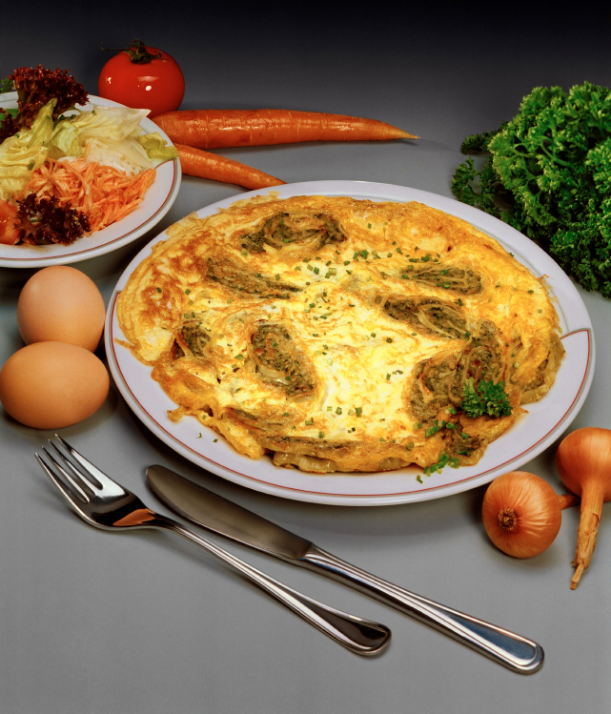 To really make scrambled eggs or omelets rich add a couple of spoonfuls of sour cream, cream cheese, or heavy cream and the beat them up. (Caution
be sure that you like this consistency in your scrambled eggs.)
 Add garlic immediately to a recipe if you want a light taste of garlic and at the end of the recipe if you want a stronger taste of garlic.

MORE CLEVER IDEAS IN NEXT PETAL POWER


